Create a workspace
When you create a workspace, you have to choose a unique name for it. You can also enter an optional description to help others understand the purpose of the workspace. A workspace image can be uploaded as a .png or .jpg file. The name, description, and icon are important for identifying the workspace and its content. The Contact list allows you to identify the people who are responsible for the workspace.
Go to browser App.powerbi.com Workspaces Click New Workspace
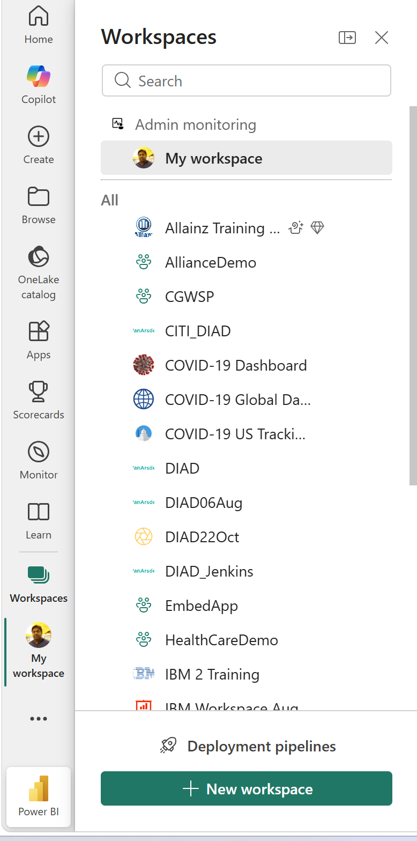
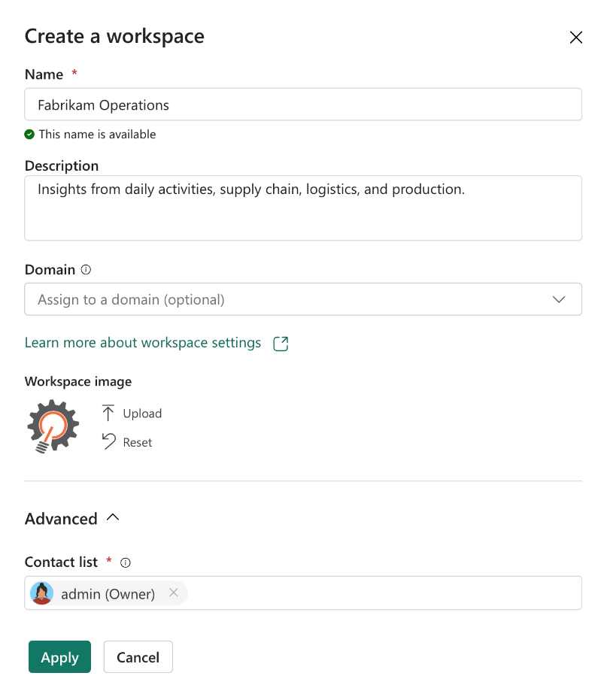
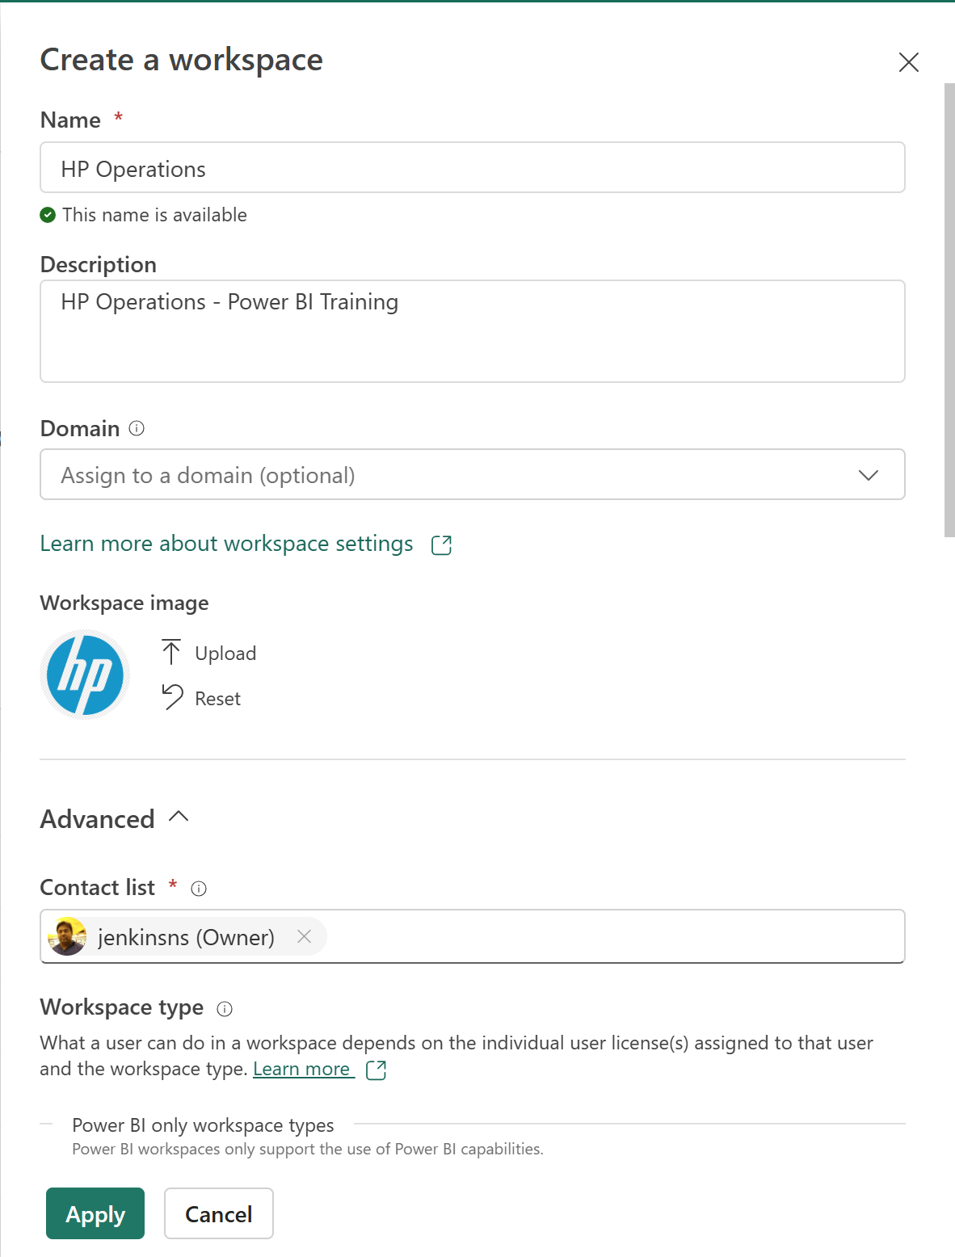
Choose a license mode for your workspace
- Power BI Pro
- Premium Per User (PPU)
- Fabric Capacity
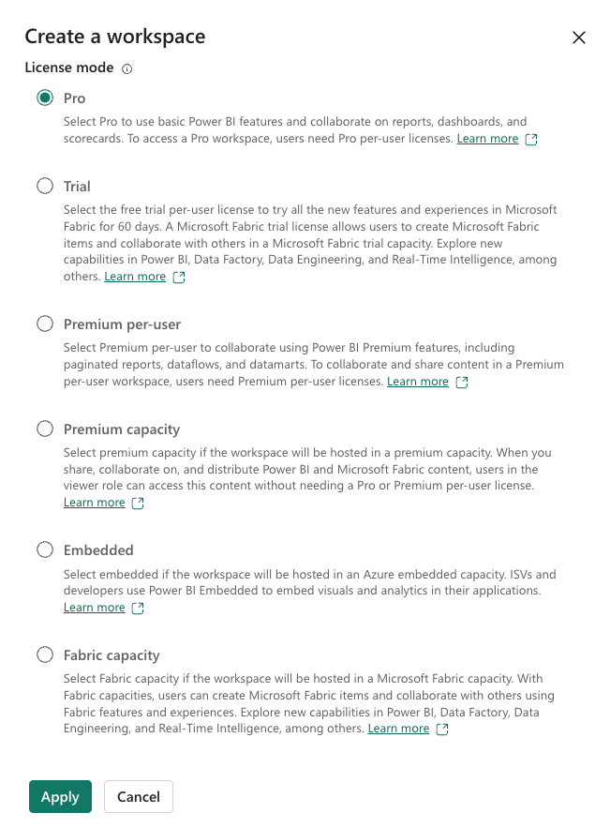
Once a workspace has been created, the diamond icon identifies Fabric workspaces. Premium Per User workspaces are identified by this diamond icon .
Grant access to a workspace
- Viewers has read-only access, allowing them to view and interact with reports and dashboards without making changes.
- Contributors can create, edit, and delete content but lacks control over app publishing, sharing, and workspace settings.
- Members can manage content, publish and update apps, share items, and modify data settings but can't delete the workspace or manage Admin roles.
- Admins have full control, including managing workspace settings, updating or deleting the workspace, adding or removing users, and controlling app publishing.
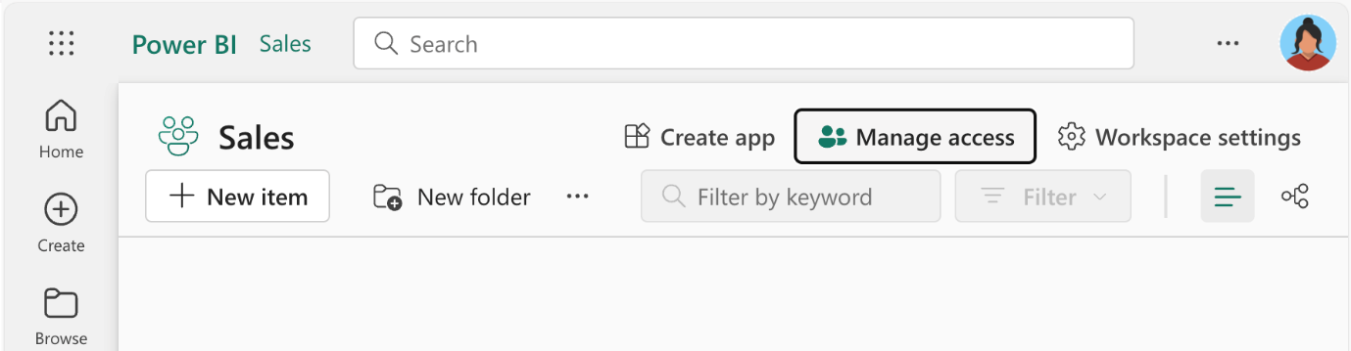

Publish to Power BI service
Imagine you have created a report in the Power BI Desktop and now you want to share it to your colleagues. Sending the .pbix file via email isn't the best option, as the file might be too large, and it can be difficult to keep track of the latest version. Also, your colleagues might not have the same version of Power BI Desktop installed, which could lead to compatibility issues.
Instead, you can publish the report to the Power BI service, where your colleagues can access it online. This process is called publishing.
Publish from Power BI Desktop
In Power BI Desktop, choose File > Publish > Publish to Power BI or select Publish on the Home ribbon.
Select Workspace

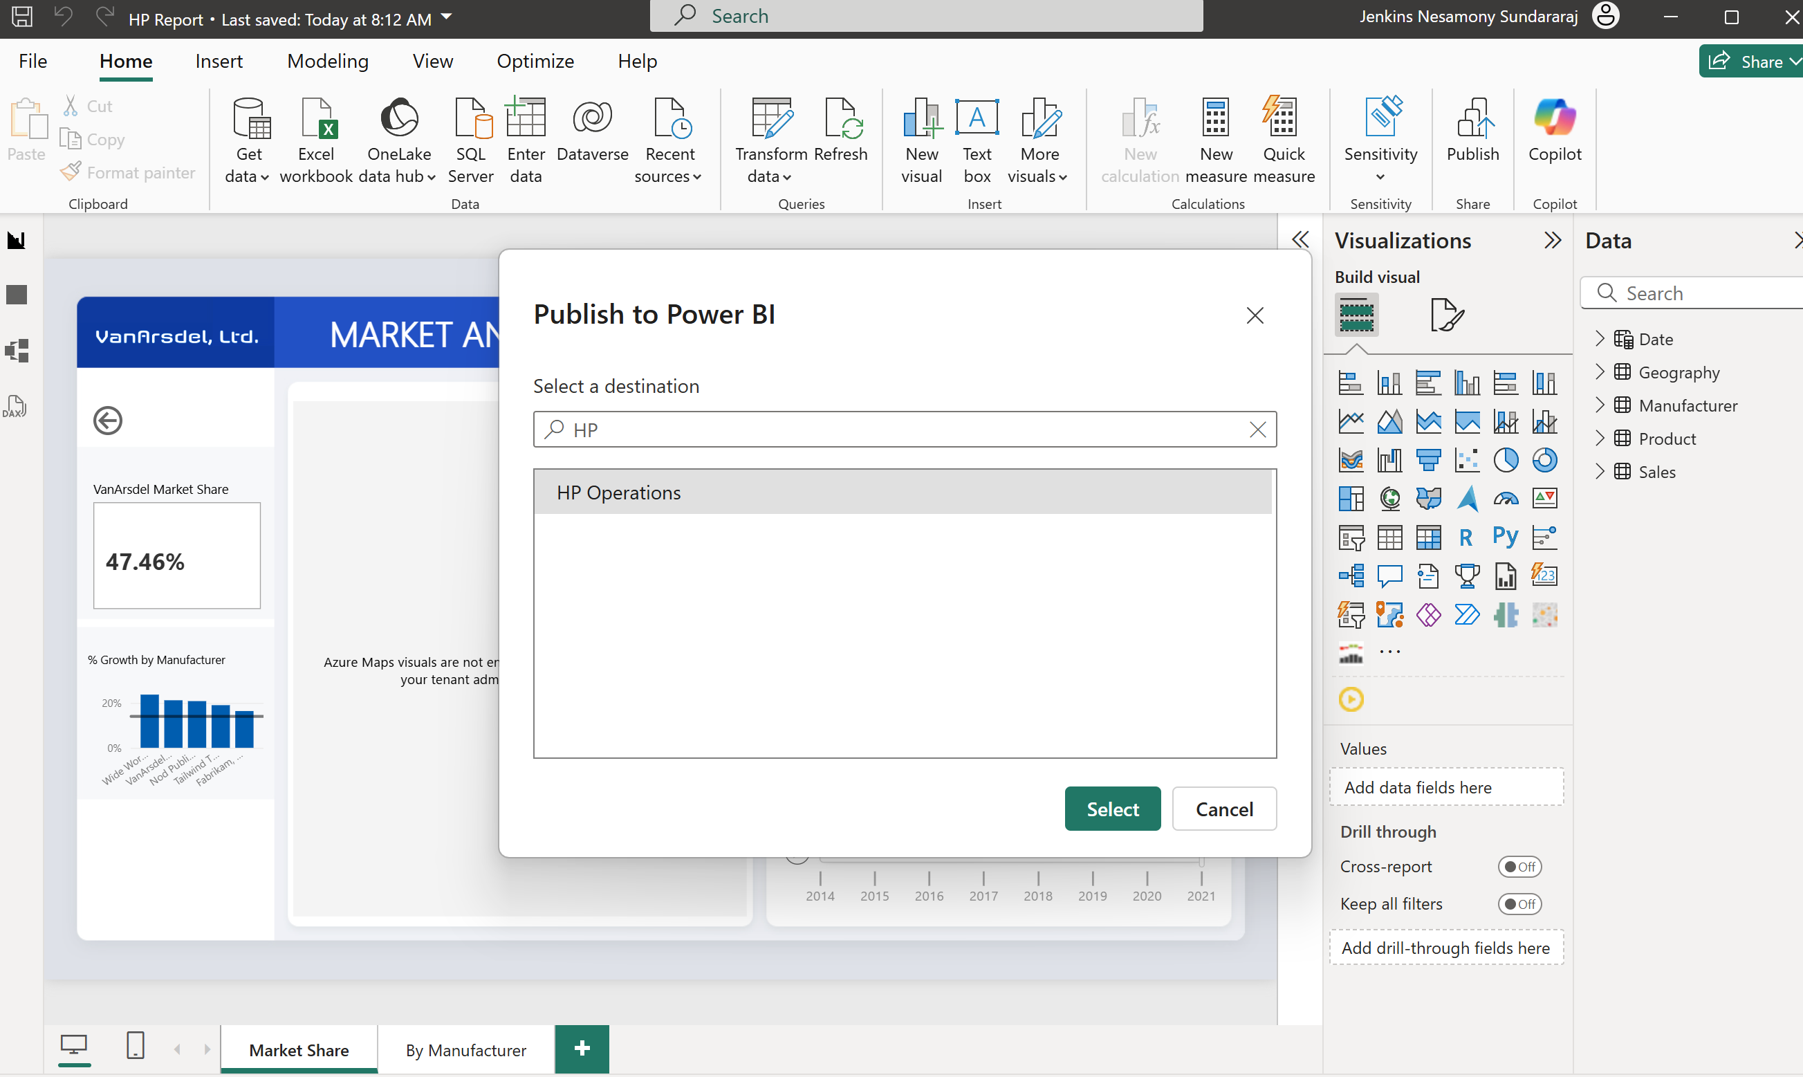
Save it
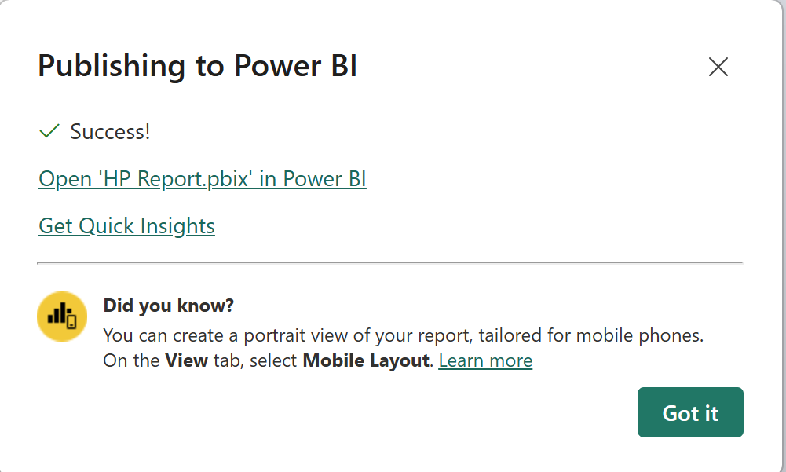

Open app.powerbi.com and the report in the workspace.
